Aviation Analysis Summary

Ashleigh Cline

# Overview

The purpose of this analysis is to serve as a data exploration exercise. The data was taken from the National Transportation Safety Board (NTSB)'s database of aviation accidents. During the span of 1982 to 2015 there were 77,257 accidents recorded by the NTSB.

This study concentrates on a subset of those accidents, in particular, incidents that occurred in the United States and involved birds. It is not uncommon for aircrafts to encounter birds in route. Take for example the 2009 flight from New York to Charlotte that was forced to land in the Hudson River after multiple bird strikes caused both of its engines to fail. Thus, this analysis aims to discover where bird-related incidents occur, how often they occur, during what phase of flight, and the amount of damage caused as a result.

# Results

## Location

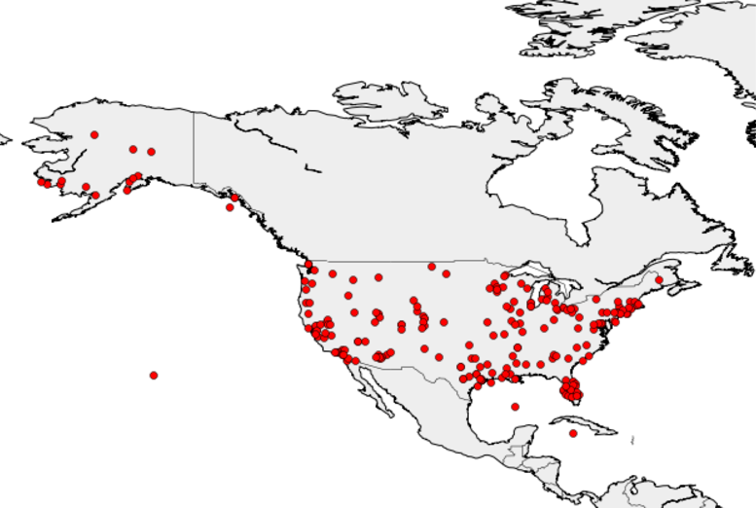Of the 77,257 accidents recorded by the NTSB, 577 were the result of bird related incidents in the US. As seen in the map to the right, there is a large amount of activity in Florida as well as moderate activity in the Northeast and California. This could indicate clusters around large coastal airports or may be indicative of migration patterns.

## Frequency

On average, there are 17 aviation accidents related to birds per year. Yet the number of incidents range from as little as 7 per year (1991, 1992) to as many as 31 (1985,2008).

## Flight Phase

Most accidents that involve birds take place during the Takeoff (100), Maneuvering (98), Cruise (96), or Approach (86) phase of flight. It is interesting to note that the Takeoff and Approach phase occur while the aircraft is below 10,000 feet above ground level. Above 10,000 feet the aircraft is in Climb or Descent unless it is at its cruising altitude. During the Climb/Descent phase a bird related accident is half as likely to occur.

## Damages

Of the bird encounters, 65% of the aircrafts suffered substantial damage and 28% were destroyed. In addition, 33% of the accidents ended in one or more fatalities.